**DIGITAL SYSTEM**

**PRACTICUM REPORT 6 : KARNAUGH MAP**



**NIM : L200183174**

**NAME : AZIE MELASARI**

**INFORMATION TECHNOLOGY**

**FACULTY OF COMMUNICATION AND INFORMATICS**

**MUHAMMADIYAH UNIVERSITY OF SURAKARTA**

**2019**

**NIM : L200183174**

**NAME : AZIE MELASARI**

**CLASS : X**

**ASSISTANT : SALSA SASMITA MUKTI**

**DATE OF PRACTICUM : Friday, April 26th 2019**

**EXERCISE 1**

|  |  |  |  |  |  |
| --- | --- | --- | --- | --- | --- |
|  | | AB | | | |
| 00 | 01 | 11 | 10 |
| CD | 00 | 0 | 0 | 0 | 0 |
| 01 | 1 | 1 | 1 | 0 |
| 11 | 0 | 1 | 1 | 1 |
| 10 | 0 | 0 | 0 | 0 |

Boolean Function : F = BD + A’C’D + ACD

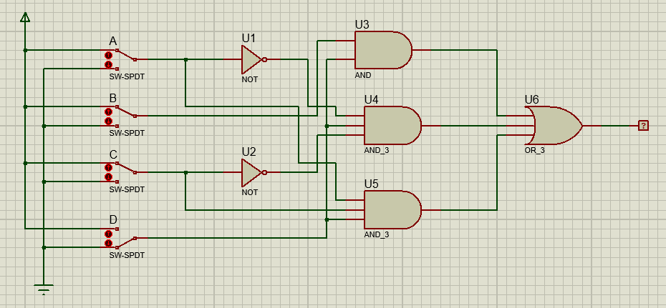

**EXERCISE 2**

|  |  |  |  |  |  |
| --- | --- | --- | --- | --- | --- |
|  | | AB | | | |
| 00 | 01 | 11 | 10 |
| CD | 00 | 1 | 0 | 0 | 1 |
| 01 | 0 | 1 | 1 | 0 |
| 11 | 0 | 1 | 1 | 0 |
| 10 | 1 | 0 | 0 | 1 |

Boolean Functoin :

F = BD + B’D’ (AND-OR)

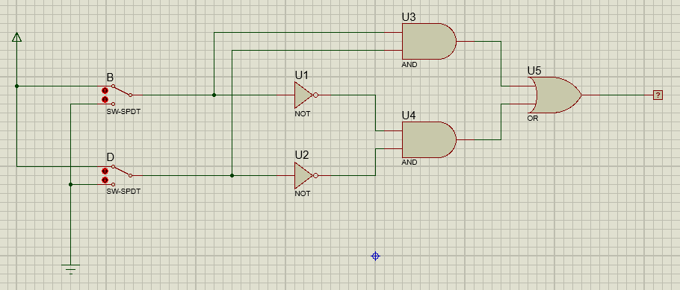

F = (B’ + D’)(B+D’) (OR-AND)

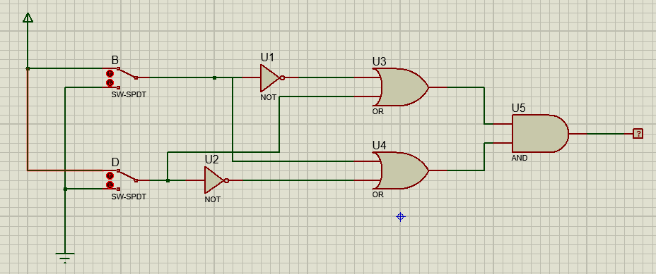

**EXERCISE 3**

|  |  |  |  |  |  |
| --- | --- | --- | --- | --- | --- |
|  | | XY | | | |
| 00 | 01 | 11 | 10 |
| Z | 0 | 1 | 1 | 1 | 1 |
| 1 | 0 | 1 | 1 | 1 |

Boolean Function : F = X + Y + Z’

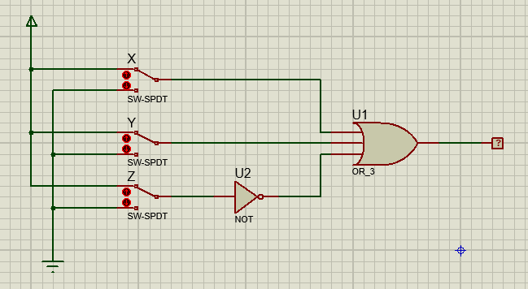

**EXERCISE 4**

|  |  |  |  |  |  |
| --- | --- | --- | --- | --- | --- |
|  | | AB | | | |
| 00 | 01 | 11 | 10 |
| CD | 00 | 0 | 1 | 1 | 1 |
| 01 | 0 | 0 | 1 | 0 |
| 11 | 0 | 1 | 1 | 0 |
| 10 | 0 | 0 | 1 | 1 |

Boolean Function : F = AB + BC’D’ + AC’D’ + BCD + ACD’

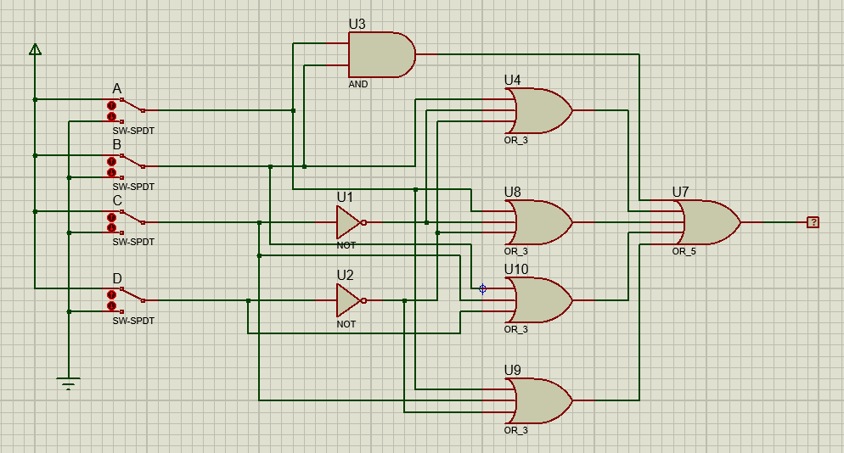

**EXERCISE 5**

|  |  |  |  |  |  |
| --- | --- | --- | --- | --- | --- |
|  | | AB | | | |
| 00 | 01 | 11 | 10 |
| CD | 00 | 1 | 0 | 1 | 0 |
| 01 | 1 | 0 | 1 | 1 |
| 11 | 1 | 1 | 0 | 0 |
| 10 | 1 | 1 | 0 | 1 |

Boolean Function : F = A’B’ + ABC’ + AC’D + A’CD + B’CD’

